Three Dimensional Persistence of Vision Display

# Introduction

The Three Dimensional Persistence of Vision Display (3DPOV Display) is a display that creates a three dimensional image by rotating LEDs at approximately 1800 rpm (30 Hz) and turning LEDs on and off at a rate which the eye can’t perceive. This action creates a 3D image to the human eye. In figure 1 is a 3D rendering of the proof of concept for the 3DPOV display, done using Autodesk Inventor. The mechanical and electrical components sit on an 18 in2, ½ inch thick wooden base. Additionally, there is a two-output power supply, separate of the base, for powering the motor and the rotating electrical components.

Excluding the wooden base, the 2DPOV display has five main components:

1. The motor assembly, a 750 KV (KV = rpm/volt) Turnigy d2836/11 DC brushless motor, a Swift 20 Amp Electronic Speed Controller (ESC), one output of the DC Power supply, and an Arduino to control the ESC
2. The timing belt assembly, a 2.7:1 timing belt configuration consisting of a 2 flange, 4mm bore, T5 5mm pitch, 10mm belt width, 10 tooth aluminum alloy timing belt pulley, a 2 flange, 3/8 inch bore, T5 5mm pitch, 10 mm belt width, 27 tooth aluminum alloy timing belt pulley, and a single sided, 61 tooth, 10 mm polyurethane steel tensile timing belt
3. The mechanical assembly, the main rotating assembly consisting of a 5/16 inch diameter, 5.1625 inch long steel rod, two 7/8” outer diameter, 5/16” inner diameter steel ball bearings, and a modified DC motor steel alloy shell
4. The power electronics assembly, a machined down 2” diameter, 1” thick super-conductive copper ring w/ a 7/16” diameter bore, a 1/16” thick, 5/16” inner diameter plastic shield between the copper ring and the steel shaft, two carbon brushes from the DC motor, and a small round PCB board containing a voltage regulator using an LM317 1.5A adjustable output linear voltage regulator to maintain 5V from a 9V input, and one output of the DC power supply
5. The main LED assembly, two PCB boards containing 16 Blue high-brightness LEDs, a MAXIM 6971 16 output constant current LED driver IC, a microcontroller (to be determined) from the stock room, a Melexis [MLX92241LUA-AAA-007-BU](http://www.digikey.com/product-detail/en/MLX92241LUA-AAA-007-BU/MLX92241LUA-AAA-007-BU-ND/3175844) 2 – wire hall effect switch.

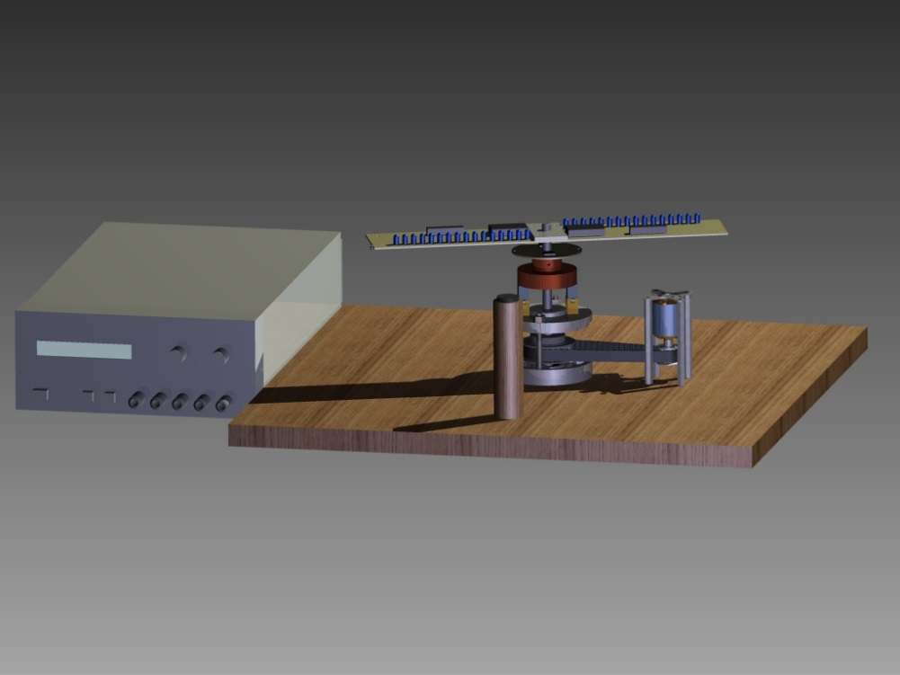

Figure 1. 3D Rendering of the 3D POV Proof of Concept using Autodesk Inventor

# Components

* Motor Assembly
* Timing Belt Pulley Assembly
* Mechanical Assembly
* Power Electronics assembly
* Main LED assembly

1. **Motor**

The motor assembly’s purpose is to generate a stable, small-changing rpm in order to drive and rotate the steel shaft. It is required that the steel shaft rotates at 30 Hz (1800 rpm).

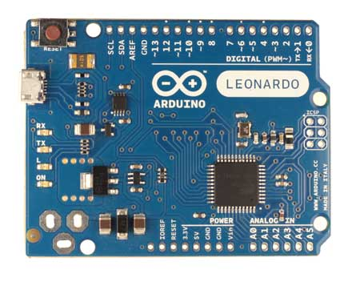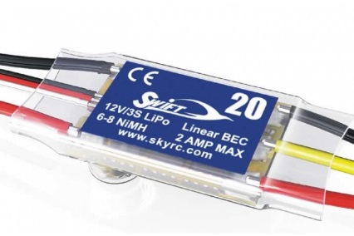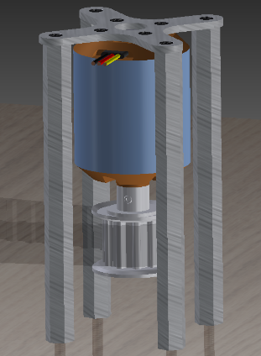

Figure 2. From left to right (a) 3D rendering of the Turnigy d2836/11 750 kV DC Brushless motor, (b) Swift 20A ESC [1], and (c) Arduino Leonardo[2]

* 1. **Turnigy d2836/11 750 kV DC Brushless Motor**

The Turnigy d2836/11 750 kV DC Brushless motor is the powerhouse for the 2DPOV Display. Its purpose is to rotate all the components at a stable speed. The motor has a 4mm shaft, a max power of 210W, and a max thrust of 800g. Component 2.1 is attached to the 4mm shaft.

* 1. **Swift 20A Electronic Speed Controller (ESC)**

The Swift 20A ESC’s purpose is to convert a DC servo control signal to a 3 phase output power for the DC Brushless motor to use. The 20A ESC has 3 outputs for the 3 connections on component 1.1, 2 connections for a battery (in our case a power supply, and a connection for component 1.3 (the three connector connection contains a signal (white), +5V from the battery elimination circuit (red), and ground (black)).

* 1. **Arduino Leonardo**

The Arduino Leonardo’s purpose is to control the speed of component 1.1 by interacting with component 1.2. The Arduino uses the built in servo library to control the esc’s speed (by emulating a throttle on an RC transmitter). Thus we can closely control the speed of the rotating parts.

1. **Timing Belt Assembly**

The timing belt assembly’s purpose is to down-convert the speed from the motor and up-convert the torque. We will be using a 2.7:1 timing belt pulley configuration to do so giving is 2.7 times more torque and 2.7 times less speed.

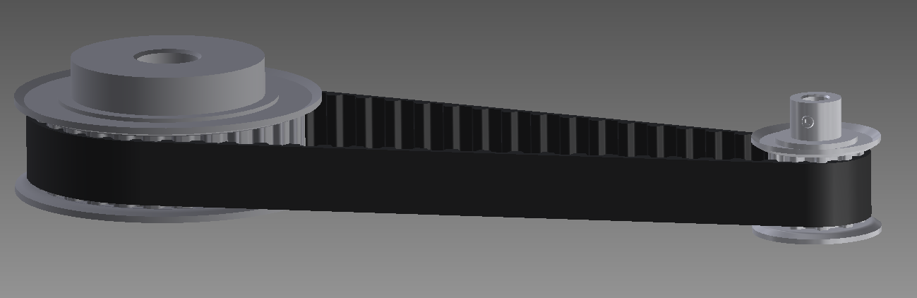

Figure 3. The timing belt pulley configuration with a 2.7:1 ratio

* 1. **Smaller Timing Belt Pulley**

The Smaller timing belt pulley is a 2 flange, 4mm bore, T5 5mm pitch, 10mm belt width, 10 tooth aluminum alloy timing belt pulley attached to component 1.1.

* 1. **Larger Timing Belt Pulley**

The larger timing belt pulley is a 2 flange, 3/8 inch bore, T5 5mm pitch, 10 mm belt width, 27 tooth aluminum alloy timing belt pulley that is connected to component 3.1.

* 1. **Timing Belt**

The timing belt is a single sided, 61 tooth, 10 mm width polyurethane steel tensile timing belt. It connects components 2.1 and 2.2 together.

1. **Mechanical Assembly**

The mechanical assembly’s purpose is to deliver a consistent, smooth, vibration free rotation for component 5. It is important for the assembly to be rigid and mechanically sound. Many components were salvaged and engineered from an old DC motor.

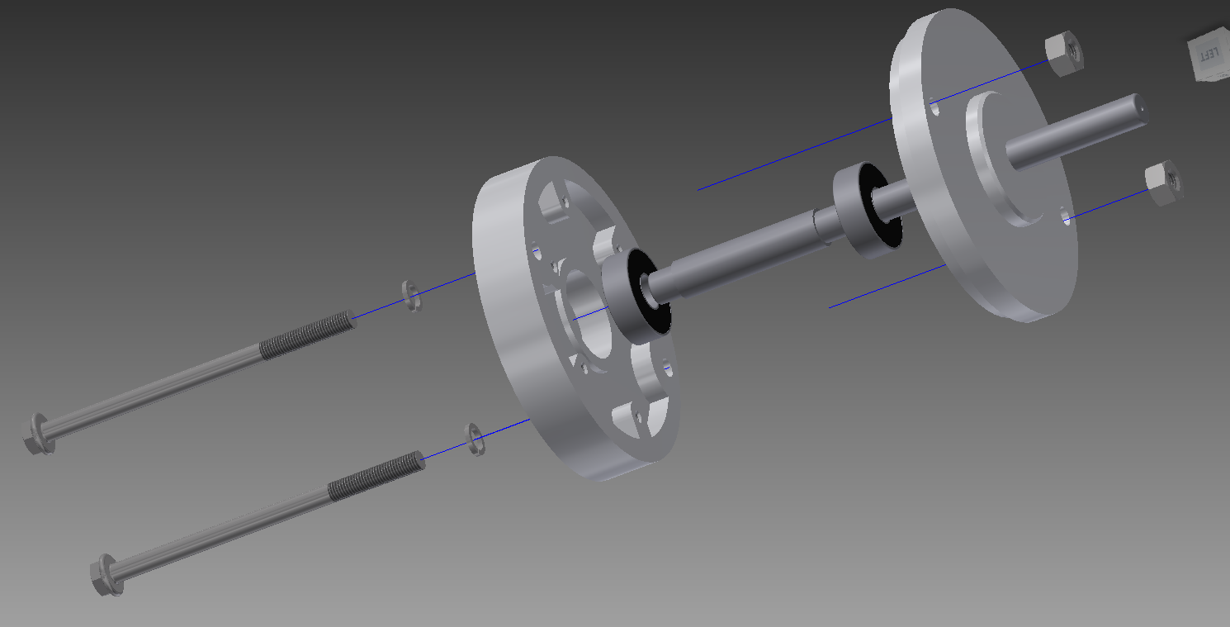

Figure 4. Exploded view of the 3D rendering of the mechanical assembly

* 1. **Steel Shaft**

The Steel shaft is the component that really holds all of the main spinning parts. It needs to be very rigid steel, with a 5/16” diameter every except between the two pulleys, where it is 3/8” diameter.

* 1. **Steel Ball Bearings**

The steel ball bearings are a critical component needed to reduce friction and to take some of the load off the shaft. The bearings are 7/8” outer diameter, 5/16” inner diameter steel ball bearings.

* 1. **DC Motor Carcass**

The DC Motor Carcass is being used as an added rigidity and mounting component. It is called the DC Motor carcass because we took apart an old DC motor, removed the rotor and the windings, and kept the rest. Components 3.1 and 3.2 are also a part of the carcass. The 2 #10 hex bolts, spring washers, and hex nuts are also from the DC Motor.

1. **Power Electronics Assembly**

The power electronics assembly’s purpose is to transfer power from a stationary power supply to the rotating components. In order to do this we use a super-conductive copper ring in conjunction with carbon graphite brushes and a linear voltage regulator.

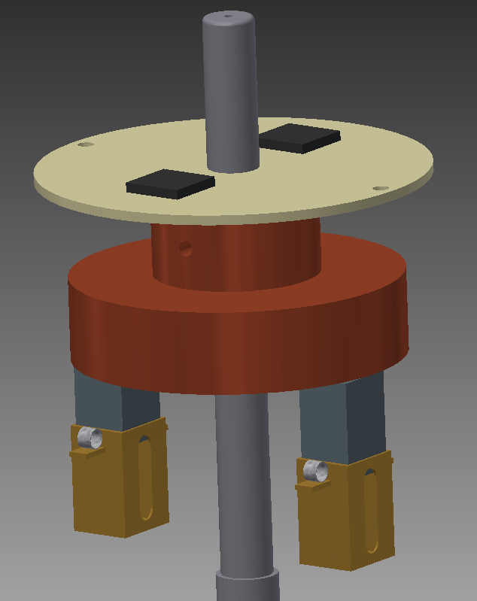Figure 5. 3D Rendering of the power electronics assembly

* 1. **Carbon Brushes**

The carbon brushes’ purpose is to transfer the power from the power supply to rotating super-conductive copper ring. The brushes sit directly onto the copper ring and will send a DC voltage into the ring (ground will be sent up the shaft). One note is that brushes are a viable solution here because we aren’t looking to have this last long term, otherwise we would have to replace the brushes as they wear down from use.

* 1. **Super-Conductive Copper Ring**

The super-conductive copper ring’s purpose is to transfer power from the brushes to the power electronics PCB board with minimal losses. The copper ring does not directly touch the shaft. The copper ring is 2 inches in diameter with a 7/16” bore through the center. Component 4.3 sits inside the bore to insulate the ring from the shaft. Also, not pictured are the connections from the copper ring to the power electronics PCB.

* 1. **Plastic Insulating Ring**

The plastic insulating ring’s purpose is to insulate the super-conductive copper ring from the steel shaft. The ring has an inner diameter of 5/16” and an outer diameter of 7/16”.

* 1. **LM317 1.5A Adjustable Output Linear Voltage Regulator**

The LM317 Linear Voltage regulator’s purpose is to take the 9V signal received from the copper ring and stabilize the output to be approximately 5V. The great feature of the voltage regulator is that we can adjust the output voltage with a potentiometer and sways in the input voltage have minimal effect on the output voltage.

1. **Main LED Assembly**

The main LED assembly is where the meat of the electronics happens. The LED assembly is rotated by components 1.0, 2.0, and 3.0 at approximately 1800 rpm and their 16 LEDs per assembly arm. In rotating the LEDs, we can generate a polar coordinate 2D plane that forms a washer shape (for the Senior Design, the idea would be to add layers to the proof of concept in order to get a 3D cylindrical coordinate system).

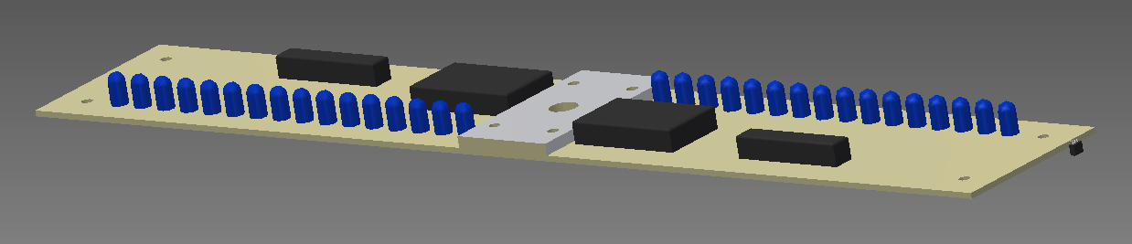

Figure 6. 3D Rendering of the Main LED Assembly

* 1. **High Brightness blue LEDs**

The purpose of the high brightness blue LEDs is to add resolution to the 2D image. There are 16 LEDs per arm.

* 1. **MAX 9671 16 Output Constant-Current LED Driver IC**

The purpose of the MAX 9671 LED Driver IC is to convert the SPI signal being sent from the microcontroller to a signal that determines whether an LED is on/off. The setup for the IC is quite simple. All that is needed is +5V and ground, as well as pull down resistor to set the LED brightness (current output). The IC can operate at 25 Mb/s.

* 1. **Microcontroller**

The purpose of the microcontroller is to communicate with the LED Driver via SPI and turn on/off the appropriate LEDs. Additionally, the microcontroller interfaces with the Hall Effect switch in order to determine when a full revolution has occurred and will trim the timings based on the sensor reading.

* 1. **Melexis** [**MLX92241LUA-AAA-007-BU**](http://www.digikey.com/product-detail/en/MLX92241LUA-AAA-007-BU/MLX92241LUA-AAA-007-BU-ND/3175844) **2-wire Hall Effect switch**

The purpose of the Hall Effect switch is to tell the microcontroller when a full rotation has been completed. There will be a stationary magnet mounted to the wooden board (seen in figure 1) that the sensor will pass once every revolution.

* 1. **Radioshack PCB and Mounting Bracket**

The two Radioshack PCB boards will be mounted together using a custom fabricated aluminum bracket. This bracket will be center bored to a diameter of 5/16” in order to mount to the steel shaft.

Image References:

[1] - http://www.skyrc.com/image/cache/data/proshow/ES20-720x480.jpg

[2] - http://arduino.cc/en/uploads/Main/LeonardoNoHeadersFront_2_450px.jpg